ECAO3O5- SIGNALS AND SYSTEMS
NAME:ASHWINRAAMVIPA
REG NO: 192512010

Experiment No.: 2
Title: Signal Operations and Transformations
Objective (i) To perform amplitude scaling and time scaling of continuous-time and discrete-time signals and analyze their effects on signal characteristics.
AIM
To perform amplitude scaling and time scaling (compression and expansion) of a signal and analyze their effects on signal characteristics using MATLAB.
APPARATUS / SOFTWARE REQUIRED
1. Computer / Laboratory PC
2. MATLAB software (with Signal Processing environment)
THEORY
Amplitude scaling multiplies the signal by a constant A, so the amplitude changes by the factor A while the shape and time period remain the same.
Time scaling changes the time axis. For x(at) with a > 1 the signal is compressed in time and its period reduces by the factor a; for x(t/a) with a > 1 the signal is expanded in time and its period increases by the factor a. For x(t) = sin(2πf₀t), the period is T₀ = 1/f₀.
FORMULAE USED
Amplitude scaling: y(t) = A x(t)
Time compression: y(t) = x(at), a > 1
Time expansion: y(t) = x(t/a), a > 1
x(t) = sin(2πf₀t), T₀ = 1/f₀
Percentage deviation = |Practical − Theoretical| / |Theoretical| × 100
PROCEDURE
- Start MATLAB and define the time vector t = −1 to 1 s with a step of 0.001 s.
- Generate the base signal x(t) = sin(2π·5·t).
- Apply amplitude scaling using A = 2 to obtain 2x(t).
- Apply time compression to obtain x(2t).
- Apply time expansion to obtain x(t/2).
- Plot the original and transformed signals using subplot with the same time axis.
- Measure the amplitude and period of each signal.
- Compare the measured results with the theoretical scaling relationships.

PROGRAM (MATLAB CODE)
% Experiment 2(i): Amplitude and Time Scaling
clc; clear; close all;
t = -1:0.001:1;
x = sin(2*pi*5*t);
yA = 2*x;
yC = sin(2*pi*5*(2*t));
yE = sin(2*pi*5*(t/2));
figure;
subplot(2,2,1); plot(t,x); grid on;
title('Original x(t)'); xlabel('Time (s)'); ylabel('Amplitude');
subplot(2,2,2); plot(t,yA); grid on;
title('Amplitude Scaling: 2x(t)'); xlabel('Time (s)'); ylabel('Amplitude');
subplot(2,2,3); plot(t,yC); grid on;
title('Time Compression: x(2t)'); xlabel('Time (s)'); ylabel('Amplitude');
subplot(2,2,4); plot(t,yE); grid on;
title('Time Expansion: x(t/2)'); xlabel('Time (s)'); ylabel('Amplitude');
OUTPUT
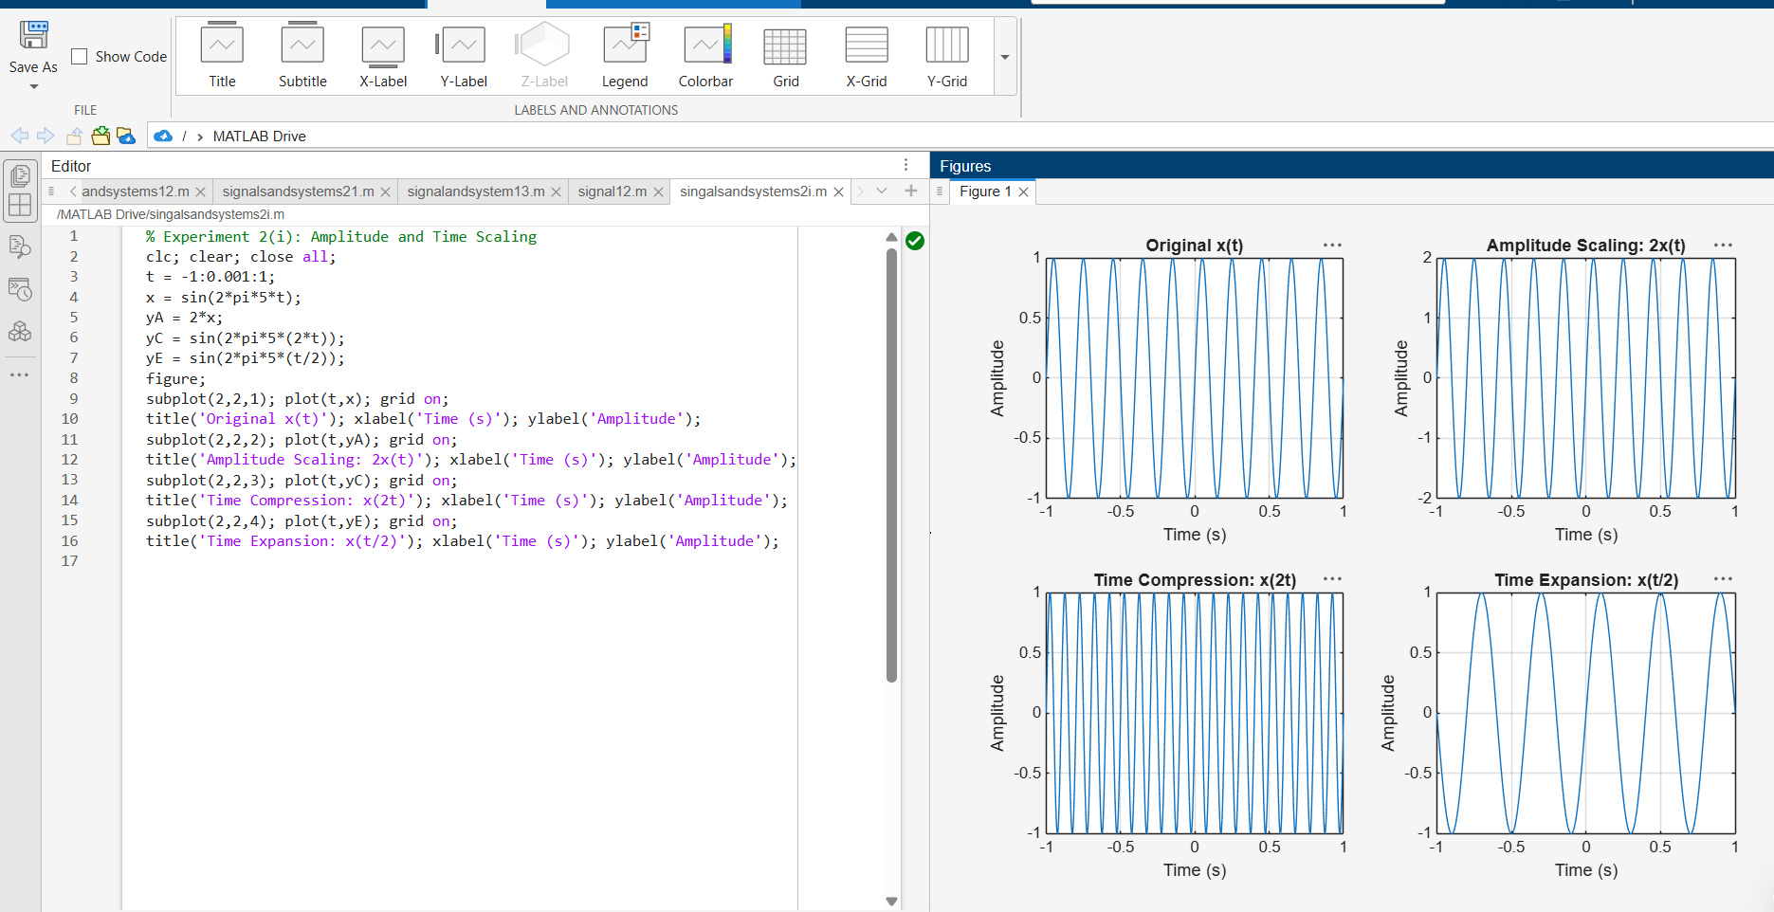
Fig. 2.1 Original signal, amplitude scaling 2x(t), time compression x(2t) and time expansion x(t/2)
RESULT
Amplitude scaling, time compression and time expansion were performed on x(t) = sin(2π5t). Scaling by A = 2 doubled the amplitude without changing the period, time compression x(2t) reduced the period from 0.2 s to 0.1 s, and time expansion x(t/2) increased it to 0.4 s, in agreement with the theoretical relationships.

Objective (iii) To perform addition and multiplication of two discrete-time sequences and analyze the resulting signal characteristics
AIM
To perform addition and multiplication of two discrete-time sequences and analyze the resulting signal characteristics using MATLAB.
APPARATUS / SOFTWARE REQUIRED
1. Computer / Laboratory PC
2. MATLAB software (with Signal Processing environment)
THEORY
Addition and multiplication of discrete-time sequences are performed sample by sample for corresponding values of the index n, so both sequences must be defined on the same (aligned) index set.
For two sequences x[n] and y[n], the sum is z[n] = x[n] + y[n] and the product is p[n] = x[n]y[n]. The product here is point-by-point multiplication and must not be confused with convolution.
FORMULAE USED
Sum: z[n] = x[n] + y[n]
Product: p[n] = x[n]·y[n]
Percentage error = |Measured − Theoretical| / |Theoretical| × 100
PROCEDURE
- Start MATLAB and define the sample index n = 0 to 2.
- Enter the sequences x[n] = {1, 2, 1} and y[n] = {1, 1, 2} with aligned indices.
- Compute the sum sequence using x + y.
- Compute the product sequence using point-wise multiplication x .* y.
- Plot the input sequences and the resulting sequences using stem plots.
- Compare the calculated samples with the manual (theoretical) results.

PROGRAM (MATLAB CODE)
% Experiment 2(iii): Addition and Multiplication of Two Sequences
clc; clear; close all;
n = 0:2;
x = [1 2 1];
y = [1 1 2];
zSum = x + y;
zProd = x .* y;
figure;
subplot(2,2,1); stem(n,x,'filled'); grid on;
title('x[n]'); xlabel('n'); ylabel('Amplitude');
subplot(2,2,2); stem(n,y,'filled'); grid on;
title('y[n]'); xlabel('n'); ylabel('Amplitude');
subplot(2,2,3); stem(n,zSum,'filled'); grid on;
title('Addition x[n]+y[n]'); xlabel('n'); ylabel('Amplitude');
subplot(2,2,4); stem(n,zProd,'filled'); grid on;
title('Multiplication x[n]y[n]'); xlabel('n'); ylabel('Amplitude');
OUTPUT
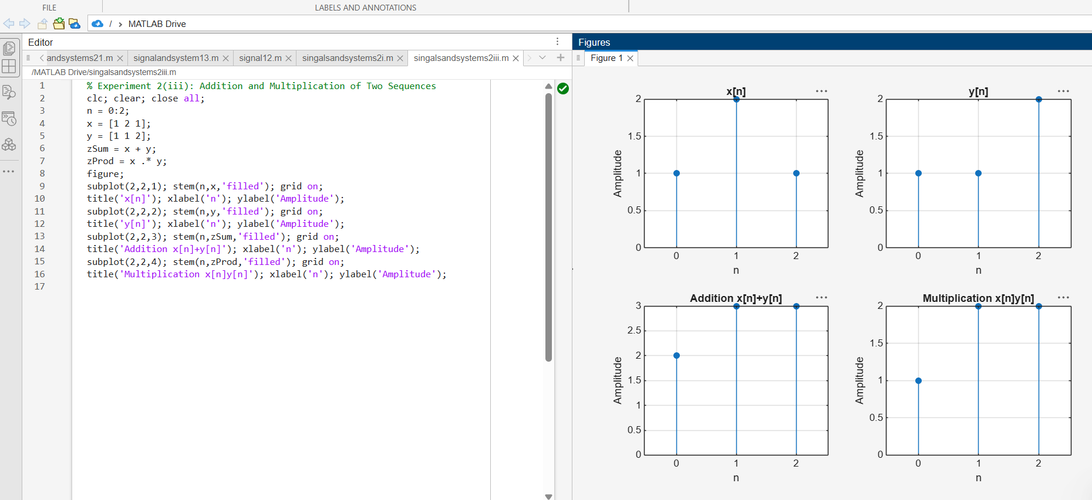
Fig. 2.2 Input sequences x[n], y[n], their sum and their product

RESULT
Addition and multiplication of the sequences x[n] = {1, 2, 1} and y[n] = {1, 1, 2} were performed in MATLAB. The sum sequence is {2, 3, 3} and the product sequence is {1, 2, 2}, which exactly match the manually calculated values

LABORATORY PERFORMANCE ASSESSMENT RUBRICS:

Objective | Assessment Criterion | Excellent – 4 | Good – 3 | Satisfactory – 2 | Needs Improvement – 1 | Weightage | Marks(10) | Marks obtained
(i) Perform amplitude scaling and time scaling of continuous-time and discrete-time signals and analyze their effects on signal characteristics. | Amplitude & Time Scaling Implementation (MATLAB) | Generates the original and scaled versions correctly for CT and DT with correct index handling. Uses plot for CT and stem for DT, with proper time and index vectors. Original and scaled plots are placed in subplots with matching axes, titles, axis labels and grid. | Generates most scaled signals correctly, with minor errors in scaling factors, index handling, axis limits or labelling. | Generates only basic scaled signals, with noticeable errors in code, time or index vectors, or plots, and needs assistance. | Unable to generate the scaled signals or produce meaningful plots. | 25 | 2.5
(i) Perform amplitude scaling and time scaling of continuous-time and discrete-time signals and analyze their effects on signal characteristics. | Analysis of Scaling Effects | Correctly explains that amplitude scaling changes amplitude and energy but not duration or period. Explains that time compression shortens duration and period (T/a) and raises frequency, that expansion does the opposite, and that a < 0 reverses time. Explains that DT scaling discards samples and needs interpolation. Supports every point with waveform evidence. | Explains most effects correctly, with minor errors or limited justification. | Gives basic observations on the effects. The explanation is incomplete and needs guidance. | Unable to analyze or explain the effects of scaling. | 25 | 2.5
(iii) Perform addition and multiplication of two discrete-time sequences and analyze the resulting signal characteristics. | Addition & Multiplication Implementation (MATLAB) | Adds and multiplies two sequences correctly even when their index ranges differ. Aligns the sequences on a common index vector with zero padding, and uses element-wise operator. Plots both inputs and the results with stem, correct n-axis, titles, axis labels and grid. | Performs both operations correctly, with minor errors in index alignment, padding, operators or labelling. | Performs the operations on simple equal-length sequences only, with noticeable errors in code or plots, and needs assistance. | Unable to perform the operations or produce meaningful stem plots. | 25 | 2.5
(iii) Perform addition and multiplication of two discrete-time sequences and analyze the resulting signal characteristics. | Analysis of Resulting Signal Characteristics | Correctly determines the amplitude, the length or range of n, and the energy of the sum and product. Explains the periodicity of the result (for example, the sum is periodic with period equal to the LCM of the two periods). Explains how multiplication acts as gating or modulation. Interprets the results clearly with waveform evidence. | Analyzes most characteristics correctly, with minor errors or limited justification. | Gives basic observations on the resulting signals. The analysis is incomplete and needs guidance. | Unable to analyze or interpret the resulting signals. | 25 | 2.5
 |  |  |  |  | Total | 100 | 10

